# **EECS545 FA2019 Project Guidelines (Public)**

**Last Update**: 2019/10/15 (v2)

*NOTE: This document only discusses guidelines for acceptable projects, suggestions for teaming, and the format for the project proposal. Additional details to come - stay tuned!*

*Any questions? Please ask in Piazza.*

## Acceptable Projects

The project can take one of the following forms:

* **[Implementation Track] Implementing a machine learning method from published papers.** You can select a **recent** journal or conference paper (JMLR, ICML, NeurIPS, ICLR, AAAI, IJCAI, etc.) on a recent ML method/algorithm, work on understanding how the method works, and implement the method on simulated or real data (not provided by the paper) to illustrate your understanding. You can also verify your implementation is correct by comparing with the reported number on the dataset used in the paper. The report will need to explain the method, describe how it is related to methods covered in class, and quantitatively and qualitatively assess its accuracy and performance.
* **[Application Track] Applying machine learning concepts learned in the course to a dataset** where either the methodology or dataset is novel and **unpublished**. The dataset should be unrestricted, non-proprietary, and not subject to IRB (Internal Review Board, e.g. involving human subjects). Kaggle challenges is a great example of this category. The analysis will have to include a comparison of **at least 3** different machine learning methods, e.g., two different classification or clustering techniques, and a thorough cross-validation analysis. Reporting of feature analysis, cross-validated goodness of fit, in addition to visualization of the features, qualitative examples, etc. will be required.
* **[Open-Ended Track] Developing a new ML algorithm, or making a substantial improvement on the existing machine learning algorithms.** Or you can try combining two different methods or learning techniques to come up with a non-trivial, better algorithm. This can be open-ended and thus challenging; this should be at a research level and potentially publishable. You should try to add novel contributions in terms of methodology, technique, or analysis, etc, and deliver some new findings.

Get started on your project early by thinking about possible topics and identifying possible partners. You can use the class discussion area of Piazza to get your ideas out and find teammates. When in doubt on the scope or the topic of project, please discuss with instructors.

## Project Responsibilities: Overview

**(1) Team Organization (September-October)**

You should self-organize into groups of **3-4 students** before mid-October based on common interest in a project topic, and start preparing a project proposal. To help you identify other students with like-interests you can use EECS545's Piazza platform, social media, or face-to-face interaction.

**(2) Project Proposal (Deadline: October 25th)**

Once you have formed a project group you will need to prepare a project proposal (see format below) and submit it by **11:59 pm Oct 25**. If you are not sure about the scope of the project, please discuss with instructors to see it will be acceptable. Submitting instructions will be provided by early October.

**(3) Reviewing Proposals (Deadline: October 31st, Thursday)**

You will be individually responsible for reviewing **3 project proposals** submitted to the same website by **11:59 pm on Oct 31**. Reviewing will be double blind --- neither the reviewers not the authors will be aware of each other's identities.

**(4) Project Report (Deadline: December 5th, Thursday)**

You will have approximately 1~1.5 month to work on your project with your team and submit a final report (see format and instructions below) by **11:59 pm Dec 5**.

**(5) Reviewing Project Reports (Deadline: December 10th, Tuesday)**

You will be individually responsible for reviewing **3 project final reports** submitted to the same website by **11:59 pm Dec. 10**. Reviewing will be double blind --- neither the reviewers not the authors will be aware of each other's identities.

**(6) Poster Presentation (December 13th)**

Your team will prepare a poster for presentation at the EECS 545 Project Poster Session on Dec 13 (12pm to 3pm). The poster must be set up by 12pm, all students should plan on being at the session for at least 1.5 hours and all posters must have at least one student available to present the poster anytime in the 3 hour session. We will provide some refreshments and drinks. There will be an **award** from sponsors for top and outstanding projects.

## Project Proposal: Guideline

The proposal document must be in a PDF file, generated by LaTeX (no MS Words, etc.). It must be written in [NeurIPS format](https://nips.cc/Conferences/2019/PaperInformation/StyleFiles). Please follow the [formatting instructions](https://media.neurips.cc/Conferences/NeurIPS2019/Styles/neurips_2019.pdf) for NeurIPS 2019. The proposal document **must be anonymized**: use “\usepackage{neurips_2019}” (no preprint, final). The proposal should be in **2-4 pages**, excluding references. Proposals that violate the formatting instruction or anonymity can hurt your score.

Your proposal should include the following sections (the order can be changed):

1. (Title and Abstract) Make sure that author list is anonymized.
2. **Introduction or Problem statement:**
   1. What is the topic or goal of your project? Why do you think it is interesting or worth pursuing? Why do you think it is not trivial?
   2. What would be the novelty or contribution of your project?
3. **Method**: Proposed approach or Methods to be developed
   1. [For the Implementation track] Explain the method (the high-level idea and optionally the technical part) on your own words, and background as much as needed (assuming the reader would have understood the topics covered in this class). A blind copy-and-paste is not allowed. Discuss why and how good this method is.
   2. [For the Application track] Which machine learning method is going to be applied?
   3. [For the Open-Ended track] Explain the method or approach you are developing. It is fine to not have a complete description.
4. **Related work**:
   1. Discuss related works (at least 5 references). A comprehensive survey of related works (either methods or practical applications) would be useful. It is important to elaborate on how they would be different from or related to your project.
   2. For example, projects in the Application track might discuss relevant works on the dataset, similar analysis. Projects in the Open-ended track should discuss relevant prior approaches and discuss how they are different from and related with your method.
5. **(Plan of) Experiments**
   1. How will you **implement** your work? List some software to be used or developed.  
      What software or off-the-shelf tools can be used? What are you going to create on your own?
   2. **Dataset** to be used (real-world data or simulated). You can discuss the nature of the dataset. How can it be obtained publicly, or how you collect/generate the data? What are the statistics of the dataset? Why is it challenging, or why would it be useful/interesting to study?
   3. **Evaluation**. How they can be evaluated? What experimental settings, dataset, evaluation metrics will you use?
6. **Plan of Project**
   1. Anticipated division of work over team.
   2. Why do you think it is accomplishable and feasible in a given timeframe? Discuss briefly. What challenges and difficulties would you expect?

## Submission Instruction on HotCRP (Added in v2)

We will use HotCRP -- an online software for managing submissions and review process. Here is the link to the submission site:

<https://umich-eecs545fa19.hotcrp.com/>

**[Step 1: Registration]** As a first user, please create an account using your email address (you must use **umich.edu** email address). Password will be sent to your email. ALL team members should register to the site individually. When signing up, please enter your first and last name correctly. Please do not enter affiliation.

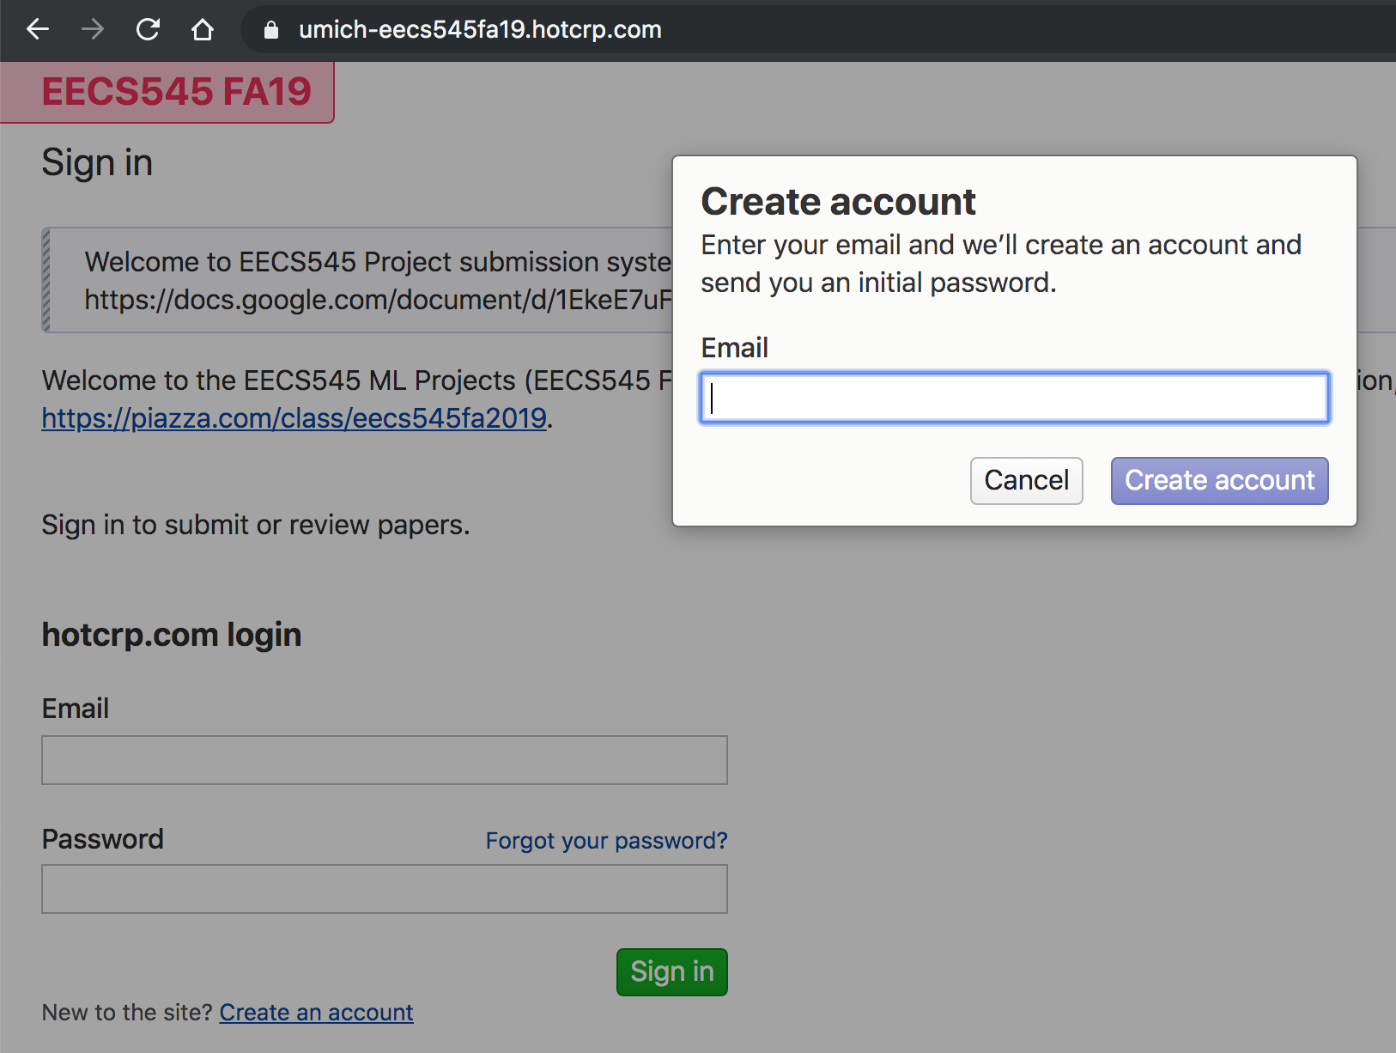

**[Step 2: Create a submission]**

Click the [New Submission](https://umich-eecs545fa19.hotcrp.com/paper/new) button: <https://umich-eecs545fa19.hotcrp.com/paper/new>.

You need to create only one submission per team. Then, enter information about your submission, including:

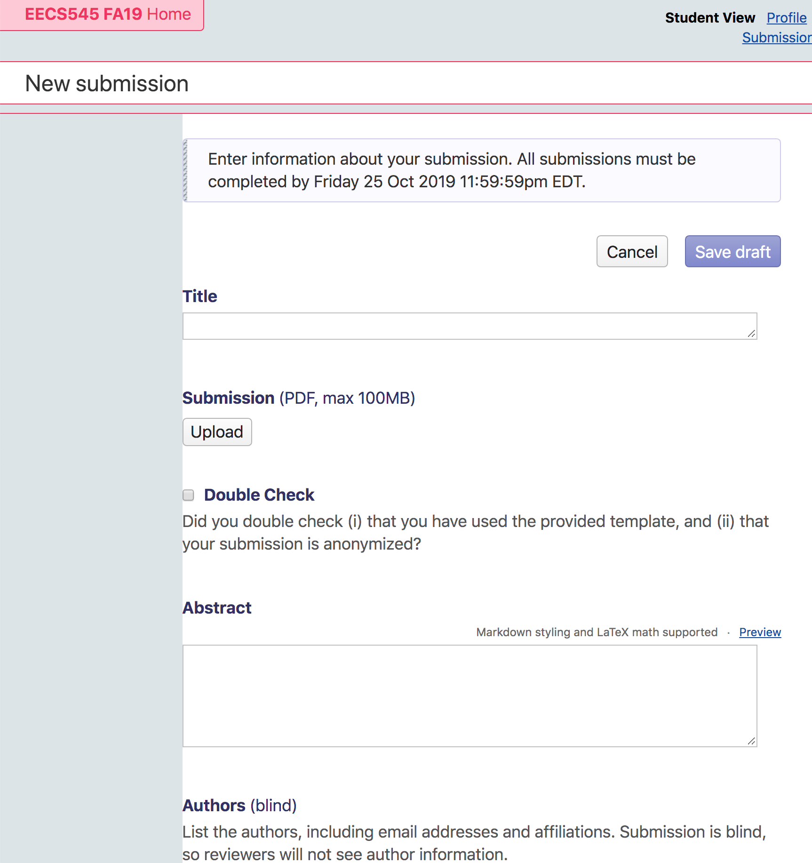

Figure: Screenshot of New submission page.

* (1) Title
* (2) “anonymized” PDF files. Make sure you used the provided NeurIPS template.
* (3) Abstract
* (4) Authors (team members):
* (5) Contacts -- leave empty
* (6) Track -- which category does your project belong to?
* (7) Collaborators / **Conflict of Interest** -- Enter your conflict of interest according to the guideline, **one per line**. Conflict of interest could arise in any situation where a person’s ability to evaluate fairly and without bias is compromised. If you believe that individuals in the class may fit this definition (e.g. your close friends), you should list them. Please follow the following format:  
    
   Jongwook Choi <[jwook@umich.edu](mailto:jwook@umich.edu)>  
   Friend Of Mine <[friend.of.mine@umich.edu](mailto:friend.of.mine@umich.edu)>
* (8) Honor Code.
* (9) Finally, please check on “**The submission is ready for review**” before you submit. If this is unchecked, your submission remains as a draft.

You are all set! Please double check whether everything is all good.

## Reviewing Process (Added in v2)

We will have two reviewing processes: one for project proposal (10/25-10/31) and another for final report (12/5-12/10).

**Review Assignment.** Each student will review 3 proposals (or final reports) that are randomly assigned. Reviewing process is double-blind: neither the reviewers not the authors will be aware of each other's identities. Review assignments will be released approximately one day after the submission deadline. Please sign in to the HotCRP site later on to check out the projects that have been assigned to you.

### Review for Proposal (~10/31)

In the first round of review (proposals), you will be asked the following review questions (see screenshots for example). Mostly your role is checking whether the submission has satisfied the provided guideline, as well as giving some constructive feedback.

Please note that text review questions are mainly intended to provide your classmates with constructive and helpful comments, rather than judgmental and overly critical evaluation of their work. Please be respectful and professional.

Please note that reviewers’ assessments are not blindly your scores. The quality of review will be also evaluated by GSIs and we will take them into account. Malicious and reviews will be penalized and we may adjust unfair reviews in such circumstances. It is important to give a constructive, positive, but critical review.

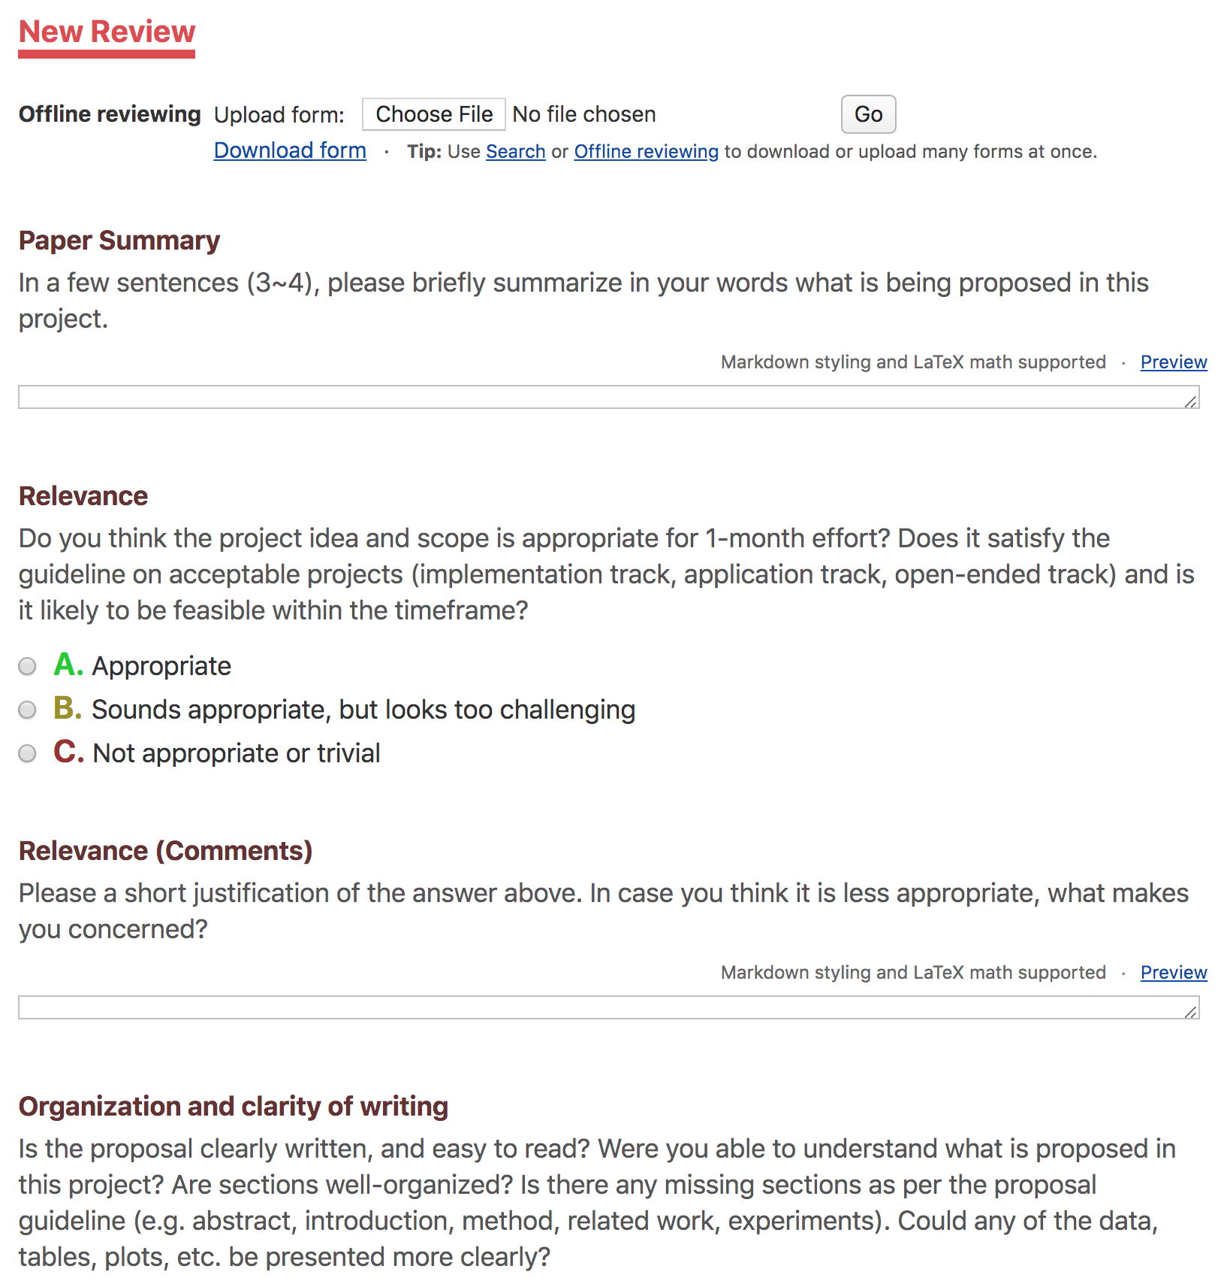

Figure: a screenshot of review questions.

Here is the preview of review questions:

|  |
| --- |
| **Paper Summary.** In a few sentences (3~4), please briefly summarize in your words what is being proposed in this project.  **Relevance.** Do you think the project idea and scope is appropriate for 1-month effort? Does it satisfy the guidelines on acceptable projects (implementation track, application track, open-ended track) and is it likely to be feasible within the timeframe?  A. Appropriate  B. Sounds appropriate, but looks too challenging  C. Not appropriate or trivial  **Relevance (Comments).** Please a short justification of the answer above. In case you think it is less appropriate, what makes you concerned?  **Organization and clarity of writing.** Is the proposal clearly written, and easy to read? Were you able to understand what is proposed in this project? Are sections well-organized? Is there any missing sections as per the proposal guideline (e.g. abstract, introduction, method, related work, experiments). Could any of the data, tables, plots, etc. be presented more clearly?  A. Strong: most of the parts are clear, well-organized, and complete in response to the guideline.  B. Moderate: some parts are unclear or needs improvement  C. Limited: difficult to understand  **Clarity of writing (Comments).** Please justify your ratings in words. Please be specific on what was unclear to you.  **Novelty.** Do you find anything novel? Please comment on the novelty this project would have.   * For open-ended track: Please discuss what is the novel contribution of the proposed idea or method. * For implementation track: Is the code (either original or third-party) available? Do you anticipate a sufficient challenge to implement them? * For application track: What would be the difference from the original paper or existing implementation? Which datasets (different from the one used in the original paper) are going to be explored?   **Plan of project.** Is the plan of implementation or experimentation well discussed? (including availability of softwares to use, datasets, evaluation/validation protocol, etc.)  A. Yes  B. No  **Reviewer Confidence.** Please select one that best describes your confidence of reviewing:  1. Not confident at all. I mostly made an educated guess.  2. I am fairly confident in my assessment. It is possible that I did not understand some parts of the submission or that I am unfamiliar with some pieces of related work.  3. I am confident in my assessment, but not absolutely certain.  4. I am absolutely certain about my assessment. I am very familiar with the method and related work.  **Additional Comments for author.**  Please provide a constructive feedback and/or additional comments for the authors. What do you think can be additionally included (in the final writeup) to improve the project, e.g. experiments, datasets, etc.? Do you have any suggestion for missing experiments?  **Confidential Comments for Instructors.** (hidden from authors)  [Optional] If you have comments that you wish to be kept confidential from the authors, please enter them here. Such comments might include explicit comparisons of the submission to other submissions, potential plagiarism or violation of honor code, or any other concerns. |

## FAQ

* How can I find teammates?
  + Please discuss in Piazza. You can also drop by Office Hours to get some help.
* I am looking for some publicly available dataset.
  + Kaggle challenge & dataset: <https://www.kaggle.com/datasets>
  + You may also find this collection useful (but “toy” datasets will be not allowed): <https://github.com/awesomedata/awesome-public-datasets>
* Can we implement some novel applications of machine learning, in Computer Vision / Natural Language Processing, Robotics, etc.?
  + Yes, as long as it is nontrivial and you address a novel problem.
* Where can I find some candidates for the ML algorithms to implement?
  + Please have a look at the recent publication list from ICML, NeurIPS, ICLR, JMLR, AAAI, CVPR, etc.
* Can we use external libraries (e.g. scikit-learn, TensorFlow, PyTorch, etc.?)
  + Yes, but it must not make your project trivial. For example, it would not make sense to just use an off-the-shelf implementation for implementation-type projects. If you are writing an ML application, autograd is allowed. However, if the algorithm is about optimization, you should implement the computation part on your own.
* Can I do project by myself?
  + No. Please work in group with 3+ students.

## Changelog

* 2019/9/18 (v1). Initial version including Scope, Overview, Proposal, FAQ.
* 2019/10/15 (v2). Add submitting instruction and reviewing process.